Xilinx ISE with myhdl Generating a Finite State Machine FSM

Now that the ISE 64 bit is working. Testing a new project with a FSM "RamCtrl.vhd" & "RamCtrl.v"
Note: With the "RamCtrl.vhd" & "pck_myhdl_09.vhd" could not get the "TBRamCtrl.vhd" to work.
The code for this will be located jpeg-2000-test/jpeg_ramctrl
Enter a Name: and depress Next.
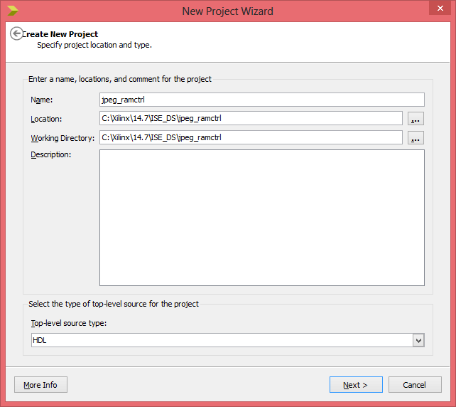

New Project. Which will is FSM that is generated with myhdl. The python code "fsmjpeg.py" is found at Appendix A. Python code to generate HDL, that generates the HDL "RamCtrl.v" is found at Appendix B. RamCtrl.v and "RamCtrl.vhd" is found at Appendix C. RamCtrl.vhd.

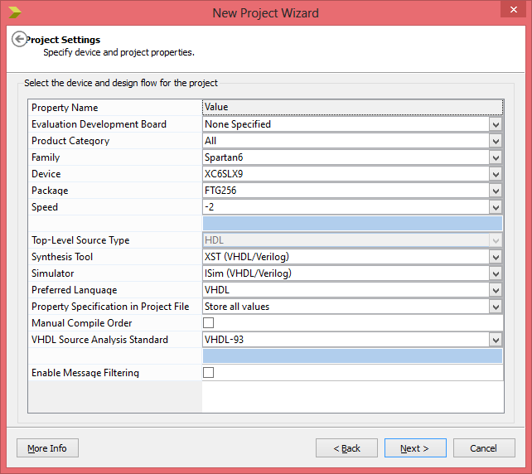

Depress Next

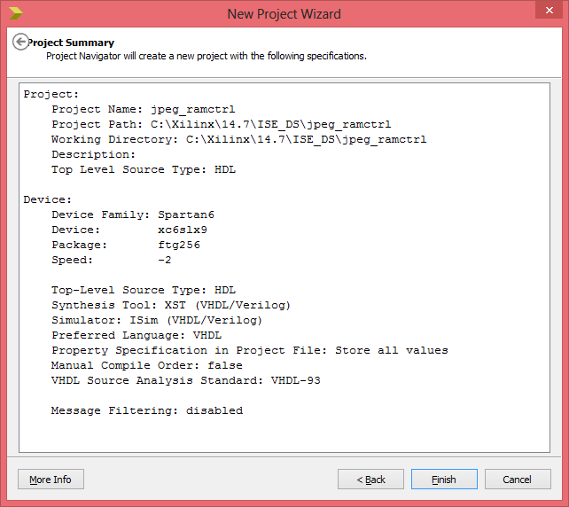

Depress Finish.
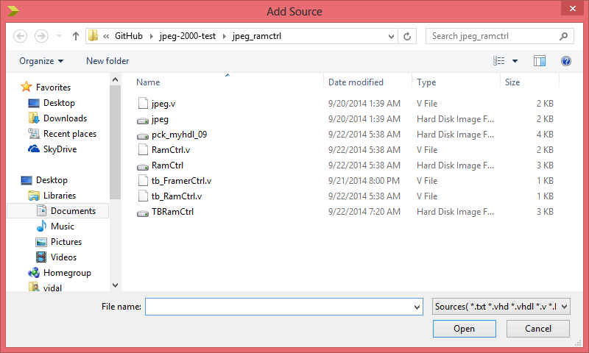
Project Add Source

New window select the file RamCtrl.vhd.

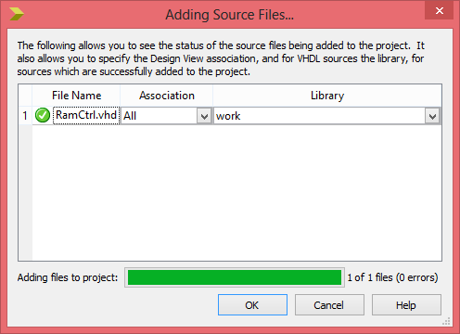

Depress OK.
Repeat the steps above to add the file pck_myhdl_09.vhd.
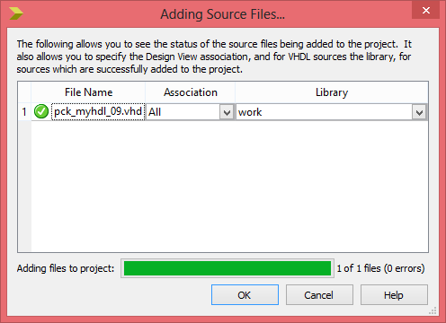
Note: With the "RamCtrl.vhd" & "pck_myhdl_09.vhd" could not get the "TBRamCtrl.vhd" to work.

Project New Add Source. Highlight VHDL Test Bench enter File name:
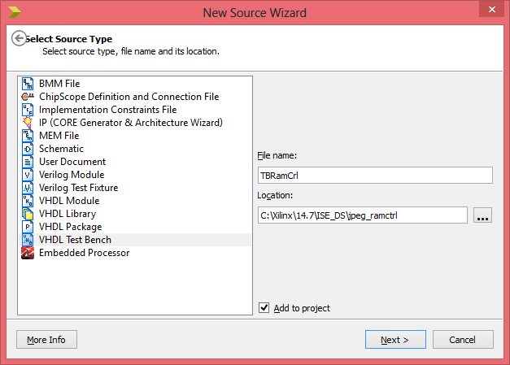
Depress Next.
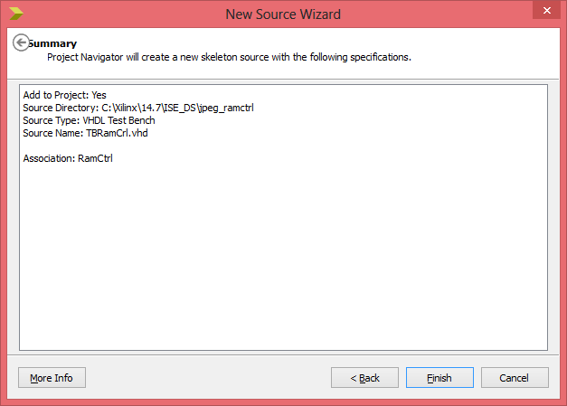

Depress Finish
In the section --insert stimulus here added the lines below.
-- insert stimulus here
reset_n <= '1';
WR_DATAFlag <= '1';
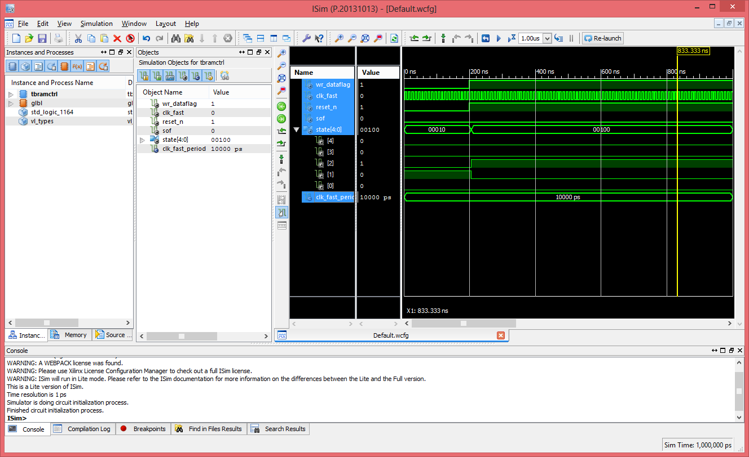

Appendix A. Python code to generate HDL
import os
path = os.path

from myhdl import *

#INIT, RD_AND_JPEG_DATA, WR_DATA, INTERLACE, DONE = range(5)
ACTIVE_LOW = bool(0)
FRAME_SIZE = 8
t_State = enum('INIT', 'RD_AND_JPEG_DATA', 'WR_DATA', 'INTERLACE', 'DONE', encoding="one_hot")

def RamCtrl(SOF, state, WR_DATAFlag, clk_fast, reset_n):

""" Framing control FSM.

SOF -- start-of-frame output bit
state -- RamState output
WR_DATAFlag -- WR_DATA pattern found indication input
clk_fast -- clock input
reset_n -- active low reset

"""

index = Signal(intbv(0)[8:]) # position in frame

@always(clk_fast.posedge, reset_n.negedge)
def FSM():
if reset_n == ACTIVE_LOW:
SOF.next = 0
index.next = 0
state.next = t_State.RD_AND_JPEG_DATA
else:
index.next = (index + 1) % FRAME_SIZE
SOF.next = 0
if state == t_State.INIT:
index.next = 1
if WR_DATAFlag:
state.next = t_State.RD_AND_JPEG_DATA
elif state == t_State.RD_AND_JPEG_DATA:
if index == 0:
if WR_DATAFlag:
state.next = t_State.WR_DATA
else:
state.next = t_State.INIT
elif state == t_State.WR_DATA:
SOF.next = 0
elif state == t_State.INTERLACE:
if index == 0:
if not WR_DATAFlag:
state.next = t_State.INIT
SOF.next = (index == FRAME_SIZE-1)
elif state == t_State.DONE:
SOF.next = 0
else:
raise ValueError("Undefined state")

return FSM

def main():

SOF = Signal(bool(0))
WR_DATAFlag = Signal(bool(0))
clk_fast = Signal(bool(0))
reset_n = Signal(bool(1))
state = Signal(t_State.INIT)

toVerilog(RamCtrl, SOF, state, WR_DATAFlag, clk_fast, reset_n)
toVHDL(RamCtrl, SOF, state, WR_DATAFlag, clk_fast, reset_n)

if __name__ == '__main__':
main()
Appendix B. RamCtrl.v
// File: RamCtrl.v
// Generated by MyHDL 0.9dev
// Date: Mon Sep 22 05:38:26 2014

`timescale 1ns/10ps

module RamCtrl (
SOF,
state,
WR_DATAFlag,
clk_fast,
reset_n
);
// Framing control FSM.
//
// SOF -- start-of-frame output bit
// state -- RamState output
// WR_DATAFlag -- WR_DATA pattern found indication input
// clk_fast -- clock input
// reset_n -- active low reset

output SOF;
reg SOF;
output [4:0] state;
reg [4:0] state;
input WR_DATAFlag;
input clk_fast;
input reset_n;

reg [7:0] index;

always @(posedge clk_fast, negedge reset_n) begin: RAMCTRL_FSM
if ((reset_n == 0)) begin
SOF <= 0;
index <= 0;
state <= 5'b00010;
end
else begin
index <= ((index + 1) % 8);
SOF <= 0;
casez (state)
5'b????1: begin
index <= 1;
if (WR_DATAFlag) begin
state <= 5'b00010;
end
end
5'b???1?: begin
if ((index == 0)) begin
if (WR_DATAFlag) begin
state <= 5'b00100;
end
else begin
state <= 5'b00001;
end
end
end
5'b??1??: begin
SOF <= 0;
end
5'b?1???: begin
if ((index == 0)) begin
if ((!WR_DATAFlag)) begin
state <= 5'b00001;
end
end
SOF <= ($signed({1'b0, index}) == (8 - 1));
end
5'b1????: begin
SOF <= 0;
end
default: begin
$finish;
end
endcase
end
end

endmodule

Appendix C. RamCtrl.vhd
-- File: RamCtrl.vhd
-- Generated by MyHDL 0.9dev
-- Date: Mon Sep 22 05:38:26 2014

package pck_RamCtrl is

attribute enum_encoding: string;

type t_enum_t_State_1 is (
INIT,
RD_AND_JPEG_DATA,
WR_DATA,
INTERLACE,
DONE
);
attribute enum_encoding of t_enum_t_State_1: type is "00001 00010 00100 01000 10000";

end package pck_RamCtrl;

library IEEE;
use IEEE.std_logic_1164.all;
use IEEE.numeric_std.all;
use std.textio.all;

use work.pck_myhdl_09.all;

use work.pck_RamCtrl.all;

entity RamCtrl is
port (
SOF: out std_logic;
state: inout t_enum_t_State_1;
WR_DATAFlag: in std_logic;
clk_fast: in std_logic;
reset_n: in std_logic
);
end entity RamCtrl;
-- Framing control FSM.
--
-- SOF -- start-of-frame output bit
-- state -- RamState output
-- WR_DATAFlag -- WR_DATA pattern found indication input
-- clk_fast -- clock input
-- reset_n -- active low reset

architecture MyHDL of RamCtrl is

constant FRAME_SIZE: integer := 8;
constant ACTIVE_LOW: integer := 0;

signal index: unsigned(7 downto 0);

begin

RAMCTRL_FSM: process (clk_fast, reset_n) is
begin
if (reset_n = '0') then
SOF <= '0';
index <= to_unsigned(0, 8);
state <= RD_AND_JPEG_DATA;
elsif rising_edge(clk_fast) then
index <= ((index + 1) mod FRAME_SIZE);
SOF <= '0';
case state is
when INIT =>
index <= to_unsigned(1, 8);
if bool(WR_DATAFlag) then
state <= RD_AND_JPEG_DATA;
end if;
when RD_AND_JPEG_DATA =>
if (index = 0) then
if bool(WR_DATAFlag) then
state <= WR_DATA;
else
state <= INIT;
end if;
end if;
when WR_DATA =>
SOF <= '0';
when INTERLACE =>
if (index = 0) then
if (not bool(WR_DATAFlag)) then
state <= INIT;
end if;
end if;
SOF <= stdl(signed(resize(index, 9)) = (FRAME_SIZE - 1));
when DONE =>
SOF <= '0';
when others =>
assert False report "End of Simulation" severity Failure;
end case;
end if;
end process RAMCTRL_FSM;

end architecture MyHDL;

WARNING:Xst:1710 - FF/Latch <index_3> (without init value) has a constant value of 0 in block <RamCtrl>. This FF/Latch will be trimmed during the optimization process.
WARNING:Xst:1895 - Due to other FF/Latch trimming, FF/Latch <index_4> (without init value) has a constant value of 0 in block <RamCtrl>. This FF/Latch will be trimmed during the optimization process.
WARNING:Xst:1895 - Due to other FF/Latch trimming, FF/Latch <index_5> (without init value) has a constant value of 0 in block <RamCtrl>. This FF/Latch will be trimmed during the optimization process.
WARNING:Xst:1895 - Due to other FF/Latch trimming, FF/Latch <index_6> (without init value) has a constant value of 0 in block <RamCtrl>. This FF/Latch will be trimmed during the optimization process.
WARNING:Xst:1895 - Due to other FF/Latch trimming, FF/Latch <index_7> (without init value) has a constant value of 0 in block <RamCtrl>. This FF/Latch will be trimmed during the optimization process.
WARNING:Xst:3002 - This design contains one or more registers/latches that are directly
incompatible with the Spartan6 architecture. The two primary causes of this is
either a register or latch described with both an asynchronous set and
asynchronous reset, or a register or latch described with an asynchronous
set or reset which however has an initialization value of the opposite
polarity (i.e. asynchronous reset with an initialization value of 1).
WARNING:Xst:1426 - The value init of the FF/Latch state_FSM_FFd2_LD hinder the constant cleaning in the block RamCtrl.
You should achieve better results by setting this init to 0.

